University of Waterloo’s Department of Anthropology and the Faculty of Arts

2010 – 2011 Lecture Series presents:

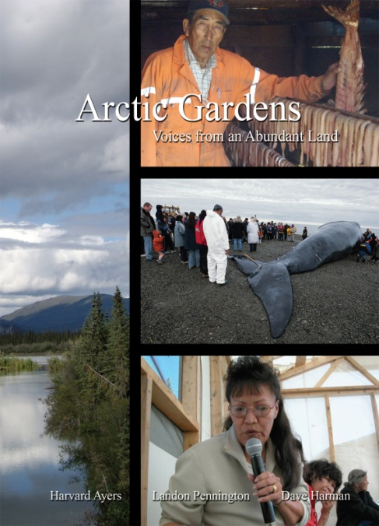
Indians, Eskimos Speak Out About Global Warming

Professor Harvard Ayers, Appalachian State University, NC
Tuesday, November 2, 2010
4:30 p.m. in PAS 1229

Meet the people most affected by petroleum development and climate change in North America. Anthropologist Harvard Ayers, businessman Dave Harman and college professor Landon Pennington interviewed 100 Native people and other residents of the Arctic region of Canada and Alaska from the Mackenzie Delta to the Chukchi Sea. These Gwich’in, Inupiat, and Inuvialuit, as well as transplants from the South, share the stories of their lives and their hopes for the future of the region.

Professor Ayers’ lecture will be based on his research for the recently published book:

Arctic Gardens:
Voices from an Abundant Land
By: Harvard Ayers, Landon Pennington,
And Dave Harman

www.arcticvoices.org. Distributed to the trade by Atlas Books

