Work Placement Opportunity

How Would You Like to Live and Work in Athens, Greece?
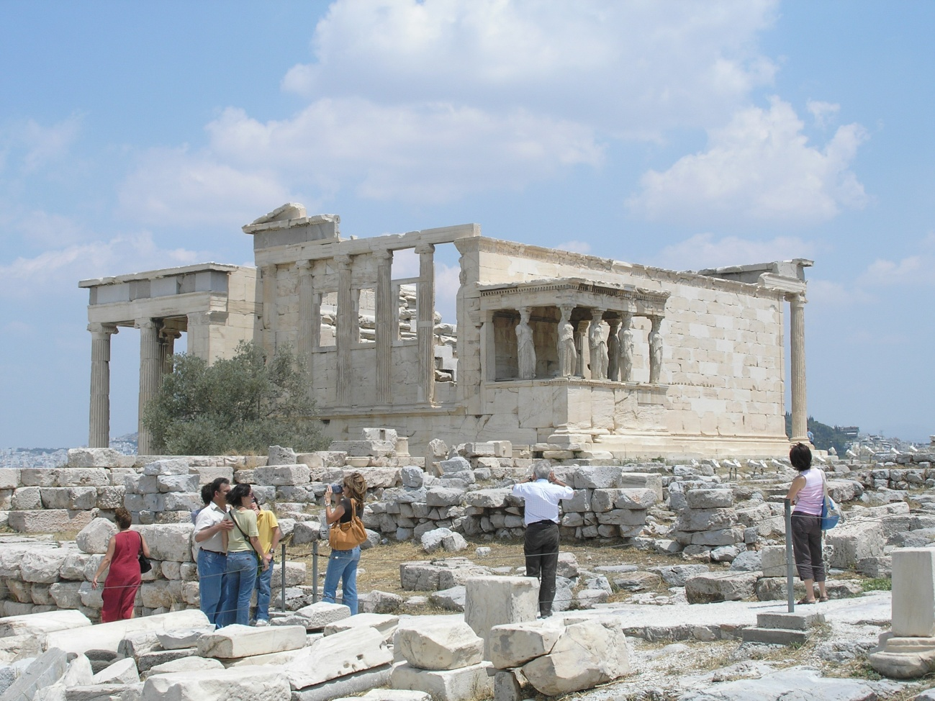
The Department of Anthropology and the Department of Classical Studies, in partnership with the Canadian Institute in Greece (CIG), are proud to offer a Work Placement opportunity for our students. The successful candidate will receive funds to work in Athens, Greece from ca. mid-January – mid-April, 2011 as an intern at CIG. You will assist in running CIG’s office and library, along with helping out with various other duties. You will have the opportunity to live in a dynamic European capital, be part of the most vibrant archaeological and Classics community in the world, and be able to visit the all the locations that you’ve only read about in class. Are you an Anthropology or Classical Studies Major, independent, hard working and looking for a wonderful personal and academic experience? If so, please send along a full c.v. (academic résumé) and a letter stating why you would be the perfect candidate for this experience to Dr. Craig Hardiman (hardiman@uwaterloo.ca) no later than Friday, October 22nd, 2010. Interviews will follow to judge the successful candidate. If you have any questions, please feel free to contact either Dr. Hardiman or Prof. Maria Liston (mliston@uwaterloo.ca).

